



DEPARTMENT OF
MASTER OF COMPUTER APPLICATIONS

OBJECT ORIENTED PROGRAMMING
USING JAVA
Experiential Learning Report

Submitted in partial fulfilment of the requirements for the I Semester MCA Experiential Learning -1 for Object Oriented Programming using Java
MCA113IA
By
M Aaryamann Prabhu (RVCE25MCA003)
&
MOHAMMED ABDULLAH SHOAIB
(RVCE25MCA090)

Under the Guidance of
Dr. Jasmine K S
Director
Department of Master of Computer Applications RV College of Engineering®
Bengaluru – 560059
December 2025


RV COLLEGE OF ENGINEERING®
(Autonomous Institution Affiliated to Visvesvaraya Technological University, Belagavi)
Bengaluru– 560059

DEPARTMENT OF
MASTER OF COMPUTER APPLICATIONS

CERTIFICATE

This is to certify that the project entitled “Stock Trading System” submitted in partial fulfillment of Experiential Learning- 1 of I Semester MCA is a result of the bonafide work carried out by by M Aaryamann Prabhu (RVCE25MCA003) and Mohammed Abdullah Shoaib (RVCE25MCA090) during the Academic year 2025-26.

Dr. Jasmine K S
Director
Department of MCA
RV College of Engineering® Bengaluru-59
Director
Associate Professor Department of MCA
RV College of Engineering® Bengaluru-59

DEPARTMENT OF
MASTER OF COMPUTER APPLICATIONS
Bengaluru– 560059

DECLARATION

We, M Aaryamann Prabhu (RVCE25MCA003) and Mohammed Abdullah Shoaib (RVCE25MCA090), students of First Semester MCA hereby declare that the Mini Project titled “Stock Trading System” has been carried out and completed successfully by us and is our original work.

Date of Submission: Signature of the Student(s)

M Aaryamann Prabhu:
USN/SAP ID: RVCE25MCA003

Mohammed Abdullah Shoaib:
USN/SAP ID: RVCE25MCA090

Evaluation Sheet

Q No | Question | Marks Assigned | Marks Obtained |  | CO | BTL
Q No | Question | Marks Assigned | M Aaryamann Prabhu | Mohammed Abdullah Shoaib | CO | BTL
1. | Identification of suitable OOPs Concept | 4 |  |  | CO1 | L1
2. | Logic used/Design Java based Solution | 4 |  |  | CO2 | L3
3. | Implementation with suitable Front-end design | 8 |  |  | CO3,  CO4 | L3,  L4
4. | Report and presentation | 4 |  |  | CO4 | L2

Course Outcomes: After completing the course, the students will be able to
CO1 | Apply object-oriented principles to design and implement real-world Java applications.
CO2 | Design Java-based solutions to achieve modular and reusable code structures.
CO3 | Analyze real-world problems and implement robust solutions using Java concepts.
CO4 | Demonstrate Java’s Collections Framework and Generics to create efficient, scalable, and type-safe data structures for software applications.

Table of Contents

SL.NO | PARTICULARS | PAGE NO
1. | ABSTRACT | 6
2. | MODULE SPECIFICATIONS | 6
3. | SOURCE CODE | 11
4. | RESULT SCREENS | 14
5. | TEST CASES | 21
6. | CONCLUSION | 25
7. | REFERENCES | 27

Stock Trading System - Project Documentation

ABSTRACT
The Stock Trading System is a comprehensive financial application designed to facilitate stock portfolio management and market data analysis. There is a critical need for individual investors to have a centralized platform that bridges the gap between complex raw market data and actionable portfolio insights. This system addresses that need by providing a multi-tier architecture that enables users to view real-time stock quotes, manage diversified portfolios with buy/sell operations, track historical transaction logs, and receive trend predictions based on market analysis. The frontend is built using Java Swing for a responsive desktop experience, while the backend leverages Spring Boot to handle business logic and external integrations. Data integrity and persistence are maintained using a dual-database approach with PostgreSQL for centralized storage and SQLite for local client-side caching. The system consists of two integrated components:
- Stock_Java - A Java Swing-based desktop client application that provides an intuitive graphical user interface for user authentication, portfolio visualization, and trading operations.
- Stock-1 - A Spring Boot RESTful backend service that integrates with the Fyers trading platform API, manages PostgreSQL database operations, and exposes endpoints for market data retrieval and portfolio management.
The project utilizes a modern technology stack and software engineering principles to ensure scalability and security. The Java Swing frontend communicates with the Spring Boot RESTful API via asynchronous HTTP requests to prevent UI freezing during data fetching. Real-time market data is fetched through third-party integration with the Fyers API. The backend employs Object-Oriented Design (OOD) with interfaces and polymorphism to manage different financial instruments, while concurrent programming and threading are used for high-frequency data updates. Security is enforced through JWT-based authentication and authorization protocols, ensuring that sensitive financial data remains protected during transit between the client and the server.
The application enables users to register accounts, log in securely, view real-time stock quotes and historical data, manage portfolios with buy/sell operations, track transaction history, and receive trend predictions based on market analysis.

MODULE SPECIFICATIONS

1. Real-Time Market Data & API Integration Module
This module serves as the primary data pipeline, bridging the Stock-1 backend with the external Fyers API. It manages the complex OAuth2 v3 authentication flow, exchanging authorization codes for secure access tokens using SHA-256 hashing. It provides high-frequency data retrieval for real-time quotes and historical OHLC (Open, High, Low, Close) candle data, which is consumed by the Stock_Java client via RESTful endpoints.

2. Centralized Portfolio & Transaction Management
This module implements the core business logic for financial operations. It handles the "Buy/Sell" execution engine, ensuring data integrity through the @Transactional annotation in Spring Boot. It manages asset allocation, calculates average buy prices, and maintains a dual-layered persistence state: PostgreSQL on the server for official records and SQLite on the client for local caching and offline visualization.

3. Predictive Trend Analysis Module
Leveraging the TrendPredictionService and ApiClient, this module performs asynchronous data fetching to avoid UI blocking. It processes historical market data through mathematical algorithms (such as moving averages) to generate a numeric trend score. This score is then visualized within the Java Swing DashboardFrame to assist users in decision-making.

4. Secure Authentication & Session Orchestration
Unlike a simple login screen, this module manages the entire lifecycle of a user session. It utilizes a HashSet<String> to track authenticated users, implements secure password hashing, and defines strict contracts through the AuthService interface. It ensures that only authorized users can access sensitive portfolio endpoints or execute trades.

SOURCE CODE

Key Files from Stock_Java

Main.java

package com;

import com.database.DatabaseManager;

import com.gui.LoginFrame;

import com.services.AuthenticationService;

import javax.swing.*;

public class Main {

public static void main(String[] args) {

try {

UIManager.setLookAndFeel(UIManager.getSystemLookAndFeelClassName());

} catch (Exception e) {

System.err.println("Could not set look and feel: " + e.getMessage());

}

DatabaseManager dbManager = new DatabaseManager();

AuthenticationService authService = new AuthenticationService(dbManager);

SwingUtilities.invokeLater(() -> {

LoginFrame loginFrame = new LoginFrame(authService);

loginFrame.setVisible(true);

});

System.out.println("Stock Trading Application Started");

System.out.println("=================================");

System.out.println("Features:");

System.out.println("- User Authentication (Login/Register)");

System.out.println("- Portfolio Management (Buy/Sell stocks)");

System.out.println("- Stock Price Prediction (Trend Analysis)");

System.out.println("- Real-time stock data fetching with threads");

System.out.println("- SQLite database for persistence");

System.out.println("- Comprehensive GUI with Swing");

}

}

AuthenticationService.java (Excerpt)
package com.services;
import com.interfaces.AuthService;
import com.models.User;
import com.database.DatabaseManager;
import java.sql.SQLException;
import java.util.HashSet;
import java.util.Set;
public class AuthenticationService implements AuthService {
private DatabaseManager dbManager;
private Set<String> authenticatedUsers; // Using Set from Collections
public AuthenticationService(DatabaseManager dbManager) {
this.dbManager = dbManager;
this.authenticatedUsers = new HashSet<>();
}
@Override
public User login(String username, String password) {
try {
User user = dbManager.getUserByUsername(username);
if (user != null && user.getPassword().equals(password)) {
authenticatedUsers.add(username);

user.setPortfolio(dbManager.getPortfolioByUserId(user.getId()));
return user;
}
} catch (SQLException e) {
System.err.println("Login error: " + e.getMessage());
}
return null;
}
@Override
public boolean register(String username, String password, String email) {
if (!isValidPassword(password)) {
System.err.println("Password does not meet security requirements.");
return false;
}
try {
User existing = dbManager.getUserByUsername(username);
if (existing != null) {
return false;
}
User newUser = new User(username, password, email);
int userId = dbManager.createUser(newUser);
return userId > 0;
} catch (SQLException e) {
System.err.println("Registration error: " + e.getMessage());
return false;
}
}
private boolean isValidPassword(String password) {
if (password == null || password.length() < 8)
return false;
boolean hasUpper = false;
boolean hasSpecial = false;
for (char c : password.toCharArray()) {
if (Character.isUpperCase(c))
hasUpper = true;
if (!Character.isLetterOrDigit(c))
hasSpecial = true;
}
return hasUpper && hasSpecial;
}
@Override
public void logout(User user) {
if (user != null) {
authenticatedUsers.remove(user.getUsername());
}
}
@Override
public boolean isAuthenticated(User user) {
return user != null && authenticatedUsers.contains(user.getUsername());
}
}

PortfolioManagementService.java (Excerpt)

package com.services;

import com.interfaces.PortfolioService;

import com.models.*;

import com.database.DatabaseManager;

import java.sql.SQLException;

import java.util.*;

public class PortfolioManagementService implements PortfolioService {

private DatabaseManager dbManager;

public PortfolioManagementService(DatabaseManager dbManager) {

this.dbManager = dbManager;

}

@Override

public boolean buyStock(Portfolio portfolio, Stock stock, int quantity) {

double totalCost = stock.getCurrentPrice() * quantity;

if (portfolio.getCashBalance() < totalCost) {

System.err.println("Insufficient funds");

return false;

}

try {

portfolio.setCashBalance(portfolio.getCashBalance() - totalCost);

portfolio.addHolding(stock.getSymbol(), quantity, stock.getCurrentPrice());

Transaction transaction = new Transaction("BUY", stock.getSymbol(), quantity, stock.getCurrentPrice());

portfolio.addTransaction(transaction);

dbManager.updatePortfolio(portfolio.getId(), portfolio.getCashBalance());

dbManager.saveHolding(portfolio.getId(), stock.getSymbol(), quantity, stock.getCurrentPrice());

dbManager.saveTransactions(portfolio.getId(), transaction);

return true;

} catch (SQLException e) {

System.err.println("Error buying stock: " + e.getMessage());

return false;

}

}

@Override

public boolean sellStock(Portfolio portfolio, String symbol, int quantity) {

Portfolio.StockHolding holding = portfolio.getHoldings().get(symbol);

if (holding == null || holding.getQuantity() < quantity) {

System.err.println("Insufficient shares");

return false;

}

try {

// For selling, we need current price - assuming we have it stored or fetched

double currentPrice = holding.getAveragePrice(); // In real app, fetch current price

double totalRevenue = currentPrice * quantity;

portfolio.setCashBalance(portfolio.getCashBalance() + totalRevenue);

portfolio.removeHolding(symbol, quantity);

Transaction transaction = new Transaction("SELL", symbol, quantity, currentPrice);

portfolio.addTransaction(transaction);

dbManager.updatePortfolio(portfolio.getId(), portfolio.getCashBalance());

Portfolio.StockHolding updatedHolding = portfolio.getHoldings().get(symbol);

int remainingQty = updatedHolding != null ? updatedHolding.getQuantity() : 0;

dbManager.updateHolding(portfolio.getId(), symbol, remainingQty);

dbManager.saveTransactions(portfolio.getId(), transaction);

return true;

} catch (SQLException e) {

System.err.println("Error selling stock: " + e.getMessage());

return false;

}

}

@Override

public double getPortfolioValue(Portfolio portfolio) {

double totalValue = portfolio.getCashBalance();

for (Portfolio.StockHolding holding : portfolio.getHoldings().values()) {

totalValue += holding.getQuantity() * holding.getAveragePrice();

}

return totalValue;

}

@Override

public List<Stock> getHoldings(Portfolio portfolio) {

List<Stock> stocks = new ArrayList<>();

for (Portfolio.StockHolding holding : portfolio.getHoldings().values()) {

Stock stock = new Stock(holding.getSymbol(), holding.getAveragePrice());

stocks.add(stock);

}

return stocks;

}

}

TrendPredictionService.java

package com.services;

import com.interfaces.StockPredictor;

import com.models.Stock;

import java.util.List;

public class TrendPredictionService implements StockPredictor {

private static final int SHORT_TERM_PERIOD = 5;

private static final int LONG_TERM_PERIOD = 10;

@Override

public String predictTrend(List<Double> historicalPrices) {

if (historicalPrices == null || historicalPrices.size() < LONG_TERM_PERIOD) {

return "NEUTRAL";

}

double shortMA = calculateMovingAverage(historicalPrices, SHORT_TERM_PERIOD);

double longMA = calculateMovingAverage(historicalPrices, LONG_TERM_PERIOD);

if (shortMA > longMA * 1.02) {

return "UP";

} else if (shortMA < longMA * 0.98) {

return "DOWN";

}

return "NEUTRAL";

}

@Override

public double predictNextPrice(Stock stock) {

List<Double> prices = stock.getHistoricalPrices();

if (prices == null || prices.isEmpty()) {

return stock.getCurrentPrice();

}

double shortMA = calculateMovingAverage(prices, SHORT_TERM_PERIOD);

double momentum = calculateMomentum(prices);

// Simple prediction based on trend continuation

return stock.getCurrentPrice() * (1 + momentum);

}

@Override

public double getConfidenceScore(List<Double> prices) {

if (prices == null || prices.size() < 10) {

return 0.5; // Low confidence

}

int consecutiveMoves = 0;

boolean isUptrend = prices.get(prices.size() - 1) > prices.get(prices.size() - 2);

for (int i = prices.size() - 1; i > 0 && i > prices.size() - 10; i--) {

boolean currentMove = prices.get(i) > prices.get(i - 1);

if (currentMove == isUptrend) {

consecutiveMoves++;

} else {

break;

}

}

return Math.min(0.5 + (consecutiveMoves * 0.08), 0.95);

}

private double calculateMovingAverage(List<Double> prices, int period) {

if (prices.size() < period) {

period = prices.size();

}

double sum = 0.0;

for (int i = prices.size() - period; i < prices.size(); i++) {

sum += prices.get(i);

}

return sum / period;

}

private double calculateMomentum(List<Double> prices) {

if (prices.size() < 2) {

return 0.0;

}

int period = Math.min(5, prices.size());

double oldPrice = prices.get(prices.size() - period);

double newPrice = prices.get(prices.size() - 1);

return (newPrice - oldPrice) / oldPrice;

}

public double calculateRSI(List<Double> prices, int period) {

if (prices.size() < period + 1) {

return 50.0; // Neutral

}

double gains = 0.0;

double losses = 0.0;

for (int i = prices.size() - period; i < prices.size(); i++) {

double change = prices.get(i) - prices.get(i - 1);

if (change > 0) {

gains += change;

} else {

losses -= change;

}

}

if (losses == 0) {

return 100.0;

}

double avgGain = gains / period;

double avgLoss = losses / period;

double rs = avgGain / avgLoss;

return 100 - (100 / (1 + rs));

}

}

User.java

package com.models;

public class User extends Person {

private String username;

private String password;

private Portfolio portfolio;

public User(String username, String password, String email) {

super(email);

this.username = username;

this.password = password;

this.portfolio = new Portfolio(10000.0); // Starting with $10,000

}

public User(int id, String username, String email, String password) {

super(id, email);

this.username = username;

this.password = password;

}

@Override

public String getRole() {

return "TRADER";

}

public String getUsername() { return username; }

public void setUsername(String username) { this.username = username; }

public String getPassword() { return password; }

public void setPassword(String password) { this.password = password; }

public Portfolio getPortfolio() { return portfolio; }

public void setPortfolio(Portfolio portfolio) { this.portfolio = portfolio; }

@Override

public String toString() {

return "User{username='" + username + "', name='" + name + "', email='" + email + "'}";

}

}

Transaction.java

package com.models;

import java.sql.Timestamp;

import java.time.LocalDateTime;

import java.time.format.DateTimeFormatter;

public class Transaction {

private int id;

private String type; // BUY or SELL

private String symbol;

private int quantity;

private double price;

private Timestamp timestamp;

public Transaction(String type, String symbol, int quantity, double price) {

this.type = type;

this.symbol = symbol;

this.quantity = quantity;

this.price = price;

this.timestamp = Timestamp.valueOf(LocalDateTime.now());

}

public Transaction(int id, String type, String symbol, int quantity, double price, Timestamp timestamp) {

this.id = id;

this.type = type;

this.symbol = symbol;

this.quantity = quantity;

this.price = price;

this.timestamp = timestamp;

}

public double getTotalAmount() {

return quantity * price;

}

public int getId() { return id; }

public String getType() { return type; }

public String getSymbol() { return symbol; }

public int getQuantity() { return quantity; }

public double getPrice() { return price; }

public Timestamp getTimestamp() { return timestamp; }

@Override

public String toString() {

DateTimeFormatter formatter = DateTimeFormatter.ofPattern("yyyy-MM-dd HH:mm");

return type + " " + quantity + " " + symbol + " @ $" +

String.format("%.2f", price) + " (" + timestamp+")";

}

}

Stock.java

package com.models;

import java.util.ArrayList;

import java.util.List;

public class Stock {

private String symbol;

private String name;

private double currentPrice;

private double openPrice;

private double highPrice;

private double lowPrice;

private long volume;

private List<Candle> historicalPrices;

private String prediction; // UP, DOWN, or NEUTRAL

public Stock(String symbol, String name, double currentPrice) {

this.symbol = symbol;

this.name = name;

this.currentPrice = currentPrice;

this.historicalPrices = new ArrayList<>();

}

public Stock(String symbol, double currentPrice) {

this(symbol, symbol, currentPrice);

}

public String getSymbol() { return symbol; }

public void setSymbol(String symbol) { this.symbol = symbol; }

public String getName() { return name; }

public void setName(String name) { this.name = name; }

public double getCurrentPrice() { return currentPrice; }

public void setCurrentPrice(double currentPrice) { this.currentPrice = currentPrice; }

public double getOpenPrice() { return openPrice; }

public void setOpenPrice(double openPrice) { this.openPrice = openPrice; }

public double getHighPrice() { return highPrice; }

public void setHighPrice(double highPrice) { this.highPrice = highPrice; }

public double getLowPrice() { return lowPrice; }

public void setLowPrice(double lowPrice) { this.lowPrice = lowPrice; }

public long getVolume() { return volume; }

public void setVolume(long volume) { this.volume = volume; }

public List<Double> getHistoricalPrices() {

List<Double> prices = new ArrayList<>();

if (historicalPrices != null) {

for (Candle c : historicalPrices) {

prices.add(c.getClose()); // Extract only the close price

}

}

return prices;

}

public void setHistoricalPrices(List<Candle> prices) { this.historicalPrices = prices; }

public void addHistoricalPrice(Candle price) { this.historicalPrices.add(price); }

public String getPrediction() { return prediction; }

public void setPrediction(String prediction) { this.prediction = prediction; }

@Override

public String toString() {

return symbol + " - $" + String.format("%.2f", currentPrice) +

(prediction != null ? " [" + prediction + "]" : "");

}

}

Portfolio.java

package com.models;

import java.util.*;

public class Portfolio {

private int id;

private double cashBalance;

private Map<String, StockHolding> holdings; // Using Map with generics

private List<Transaction> transactionHistory; // Using List with generics

public Portfolio(double initialCash) {

this.cashBalance = initialCash;

this.holdings = new HashMap<>();

this.transactionHistory = new ArrayList<>();

}

public Portfolio(int id, double cashBalance) {

this.id = id;

this.cashBalance = cashBalance;

this.holdings = new HashMap<>();

this.transactionHistory = new ArrayList<>();

}

public void addHolding(String symbol, int quantity, double price) {

if (holdings.containsKey(symbol)) {

StockHolding holding = holdings.get(symbol);

holding.addQuantity(quantity, price);

} else {

holdings.put(symbol, new StockHolding(symbol, quantity, price));

}

}

public boolean removeHolding(String symbol, int quantity) {

if (!holdings.containsKey(symbol)) {

return false;

}

StockHolding holding = holdings.get(symbol);

if (holding.getQuantity() < quantity) {

return false;

}

holding.removeQuantity(quantity);

if (holding.getQuantity() == 0) {

holdings.remove(symbol);

}

return true;

}

public double getTotalValue(Map<String, Double> currentPrices) {

double stockValue = 0.0;

for (StockHolding holding : holdings.values()) {

Double price = currentPrices.get(holding.getSymbol());

if (price != null) {

stockValue += holding.getQuantity() * price;

}

}

return cashBalance + stockValue;

}

public void addTransaction(Transaction transaction) {

transactionHistory.add(transaction);

}

public int getId() { return id; }

public void setId(int id) { this.id = id; }

public double getCashBalance() { return cashBalance; }

public void setCashBalance(double cashBalance) { this.cashBalance = cashBalance; }

public Map<String, StockHolding> getHoldings() { return holdings; }

public List<Transaction> getTransactionHistory() { return transactionHistory; }

public static class StockHolding {

private String symbol;

private int quantity;

private double averagePrice;

public StockHolding(String symbol, int quantity, double price) {

this.symbol = symbol;

this.quantity = quantity;

this.averagePrice = price;

}

public void addQuantity(int qty, double price) {

double totalValue = (quantity * averagePrice) + (qty * price);

quantity += qty;

averagePrice = totalValue / quantity;

}

public void removeQuantity(int qty) {

quantity -= qty;

}

public String getSymbol() { return symbol; }

public int getQuantity() { return quantity; }

public double getAveragePrice() { return averagePrice; }

@Override

public String toString() {

return symbol + ": " + quantity + " shares @ $" + String.format("%.2f", averagePrice);

}

}

}

Person.java

package com.models;

import java.io.Serializable;

public abstract class Person implements Serializable {

protected int id;

protected String name;

protected String email;

public Person(String email) {

this.email = email;

}

public Person(int id, String email) {

this.id = id;

this.email = email;

}

public int getId() { return id; }

public void setId(int id) { this.id = id; }

public String getName() { return name; }

public void setName(String name) { this.name = name; }

public String getEmail() { return email; }

public void setEmail(String email) { this.email = email; }

@Override

public String toString() {

return "Person{id=" + id + ", name='" + name + "', email='" + email + "'}";

}

}

Candle.java

package com.models;

import java.time.Instant;

import java.time.ZoneId;

import java.time.format.DateTimeFormatter;

public class Candle {

private long timestamp;

private double open;

private double high;

private double low;

private double close;

private long volume;

public Candle(long timestamp, double open, double high, double low, double close, long volume) {

this.timestamp = timestamp;

this.open = open;

this.high = high;

this.low = low;

this.close = close;

this.volume = volume;

}

public double getClose() { return close; }

public long getTimestamp() { return timestamp; }

public String getDate() {

return Instant.ofEpochSecond(timestamp)

.atZone(ZoneId.systemDefault())

.format(DateTimeFormatter.ofPattern("yyyy-MM-dd"));

}

public double getOpen() {

return open;

}

public void setOpen(double open) {

this.open = open;

}

public double getHigh() {

return high;

}

public void setHigh(double high) {

this.high = high;

}

public double getLow() {

return low;

}

public void setLow(double low) {

this.low = low;

}

public long getVolume() {

return volume;

}

public void setVolume(long volume) {

this.volume = volume;

}

public void setTimestamp(long timestamp) {

this.timestamp = timestamp;

}

public void setClose(double close) {

this.close = close;

}

}

ApiClient.java

package com.api;

import java.net.URI;

import com.models.Candle;

import java.net.http.HttpClient;

import java.net.http.HttpRequest;

import java.net.http.HttpResponse;

import java.time.Duration;

import java.util.*;

import com.models.Stock;

import org.json.JSONArray;

import org.json.JSONObject;

public class ApiClient {

private static final String BASE_URL = "http://localhost:8080";

private static final HttpClient client = HttpClient.newBuilder()

.connectTimeout(Duration.ofSeconds(10))

.build();

public static String getLiveQuote(String symbol) {

String endpoint = "/fyers/quote?symbol=" + symbol;

return sendGetRequest(endpoint);

}

public static String getHistory(String symbol) {

String endpoint = "/fyers/history?symbol=" + symbol;

return sendGetRequest(endpoint);

}

static String getMyHoldings() {

return sendGetRequest("/portfolio/holdings");

}

private static String sendGetRequest(String endpoint) {

try {

HttpRequest request = HttpRequest.newBuilder()

.uri(URI.create(BASE_URL + endpoint))

.GET()

.build();

HttpResponse<String> response = client.send(request, HttpResponse.BodyHandlers.ofString());

if (response.statusCode() == 200) {

return response.body(); // Returns the JSON String

} else {

System.err.println("API Error: " + response.statusCode());

return null;

}

} catch (Exception e) {

e.printStackTrace();

return null;

}

}

public Map<String, Stock> fetchMultipleStocks(List<String> symbolList) {

Map<String, Stock> stockMap = new HashMap<>();

String joinedSymbols = String.join(",", symbolList);

String jsonResponse = getLiveQuote(joinedSymbols);

if (jsonResponse == null || jsonResponse.isEmpty()) {

return stockMap; // Return empty map on failure

}

try {

JSONObject root = new JSONObject(jsonResponse);

JSONArray dataArray = root.getJSONArray("d");

for (int i = 0; i < dataArray.length(); i++) {

JSONObject item = dataArray.getJSONObject(i);

String symbol = item.getString("n");

JSONObject values = item.getJSONObject("v");

double price = values.optDouble("lp", 0.0);

double change = values.optDouble("chp", 0.0);

Stock stock = new Stock(symbol, price);

stockMap.put(symbol, stock);

}

} catch (Exception e) {

System.err.println("Error parsing stock data: " + e.getMessage());

e.printStackTrace();

}

return stockMap;

}

public static List<Candle> fetchStockHistory(String symbol) {

List<Candle> candles = new ArrayList<>();

String jsonResponse = getHistory(symbol);

if (jsonResponse == null || jsonResponse.isEmpty()) {

System.err.println("History Error: Received empty response for " + symbol);

return candles;

}

try {

if (!jsonResponse.trim().startsWith("{")) {

System.err.println("History Error: Server returned text instead of JSON: " + jsonResponse);

return candles; // Stop here, don't crash

}

JSONObject root = new JSONObject(jsonResponse);

if (root.has("candles")) {

JSONArray arr = root.getJSONArray("candles");

for (int i = 0; i < arr.length(); i++) {

JSONArray point = arr.getJSONArray(i);

long timestamp = point.getLong(0);

double open = point.getDouble(1);

double high = point.getDouble(2);

double low = point.getDouble(3);

double close = point.getDouble(4);

long volume = point.getLong(5);

candles.add(new Candle(timestamp, open, high, low, close, volume));

}

}

} catch (Exception e) {

System.err.println("Error parsing history JSON for " + symbol + ": " + e.getMessage());

}

return candles;

}

}

DatabaseManager.java

package com.database;

import com.models.*;

import java.sql.*;

import java.time.LocalDateTime;

public class DatabaseManager {

private static final String DB_URL = "jdbc:postgresql://localhost:5432/stock";

private static final String DB_USER = "postgres"; // Often "postgres"

private static final String DB_PASSWORD = "openaudit@123";

private Connection con;

public DatabaseManager() {

try {

Class.forName("org.postgresql.Driver");

con = DriverManager.getConnection(DB_URL, DB_USER, DB_PASSWORD);

System.out.println("Connection successful!");

initializeTables();

} catch (Exception e) {

System.err.println("Connection failed!");

// Print the full error to see what went wrong

e.printStackTrace();

}

}

public Connection getConnection() {

return this.con;

}

public void initializeTables() throws SQLException {

Statement stat = con.createStatement();

stat.execute("CREATE TABLE IF NOT EXISTS users("+

"id SERIAL PRIMARY KEY,"+

"username VARCHAR(50) NOT NULL,"+

"email VARCHAR(100) NOT NULL,"+

"password VARCHAR(100) NOT NULL)");

stat.execute("CREATE TABLE IF NOT EXISTS portfolio("

+ "id SERIAL PRIMARY KEY,"

+ "user_id INTEGER NOT NULL,"

+ "cash_acc FLOAT NOT NULL, "

+ "FOREIGN KEY (user_id) REFERENCES users (id))");

stat.execute("CREATE TABLE IF NOT EXISTS stock("

+ "id SERIAL PRIMARY KEY,"

+ "portfolio_id INTEGER NOT NULL,"

+ "symbl VARCHAR(20) NOT NULL,"

+ "price FLOAT NOT NULL,"

+ "qty INTEGER NOT NULL,"

+ "avg_price FLOAT NOT NULL,"

+ "FOREIGN KEY(portfolio_id) REFERENCES portfolio(id))");

stat.execute("CREATE TABLE IF NOT EXISTS holdings("

+ "id SERIAL PRIMARY KEY,"

+ "portfolio_id INTEGER NOT NULL,"

+ "symbl VARCHAR(20) NOT NULL,"

+ "qty INTEGER NOT NULL,"

+ "avg_price FLOAT NOT NULL,"

+ "FOREIGN KEY (portfolio_id) REFERENCES portfolio(id))");

stat.execute("CREATE TABLE IF NOT EXISTS transactions("

+ "id SERIAL PRIMARY KEY,"

+ "portfolio_id INTEGER NOT NULL,"

+ "symbl VARCHAR(20) NOT NULL,"

+ "type VARCHAR(10) NOT NULL,"

+ "qty INTEGER NOT NULL,"

+ "price FLOAT NOT NULL,"

+ "timestamp TIMESTAMPTZ NOT NULL,"

+ "FOREIGN KEY (portfolio_id) REFERENCES portfolio(id))");

stat.close();

}

public int createUser(User user) throws SQLException{

String psql = "INSERT INTO users(username, email, password) VALUES (?,?,?)";

PreparedStatement stmt = con.prepareStatement(psql, Statement.RETURN_GENERATED_KEYS);

stmt.setString(1, user.getUsername());

stmt.setString(2, user.getEmail());

stmt.setString(3, user.getPassword());

stmt.executeUpdate();

ResultSet rs = stmt.getGeneratedKeys();

int userId = rs.next() ?rs.getInt(1) : -1;

stmt.close();

if(userId>0) createPortfolio(userId,10000.0);

return userId;

}

public User getUserByUsername(String username) throws SQLException{

String psql = "SELECT * FROM users WHERE username = ?";

PreparedStatement stmt = con.prepareStatement(psql);

stmt.setString(1,username);

ResultSet rs = stmt.executeQuery();

User user = null;

if(rs.next()) {

user = new User(

rs.getInt("id"),

rs.getString("username"),

rs.getString("email"),

rs.getString("password")

);

}

stmt.close();

return user;

}

public int createPortfolio(int userId, double amount) throws SQLException {

String psql = "INSERT INTO portfolio (user_id, cash_acc) VALUES (?,?)";

PreparedStatement stmt = con.prepareStatement(psql, Statement.RETURN_GENERATED_KEYS);

stmt.setInt(1, userId);

stmt.setDouble(2,amount);

stmt.executeUpdate();

ResultSet rs = stmt.getGeneratedKeys();

int portfolioId = rs.next()? rs.getInt(1):-1;

stmt.close();

return portfolioId;

}

public Portfolio getPortfolioByUserId(int userId) throws SQLException{

String psql = "SELECT * FROM portfolio WHERE user_id = ?";

PreparedStatement stmt = con.prepareStatement(psql);

stmt.setInt(1, userId);

ResultSet rs = stmt.executeQuery();

Portfolio pf = null;

if(rs.next()) {

pf = new Portfolio(rs.getInt("id"), rs.getDouble("cash_acc"));

loadHoldings(pf);

loadTransactions(pf);

}

stmt.close();

return pf;

}

public void updatePortfolio(int portfolioId, double amount) throws SQLException{

String psql = "UPDATE portfolio SET cash_acc = ? WHERE id =?";

PreparedStatement stmt = con.prepareStatement(psql);

stmt.setDouble(1,amount);

stmt.setInt(2, portfolioId);

stmt.executeUpdate();

stmt.close();

}

public void loadHoldings(Portfolio portfolio) throws SQLException{

String psql = "SELECT * from holdings WHERE portfolio_id = ?";

PreparedStatement stmt = con.prepareStatement(psql);

stmt.setInt(1, portfolio.getId());

ResultSet rs = stmt.executeQuery();

while(rs.next()) {

portfolio.addHolding(

rs.getString("symbl"),

rs.getInt("qty"),

rs.getDouble("avg_price")

);

}

stmt.close();

}

public void saveHolding(int portfolioId, String symbol, int quantity, double price)throws SQLException{

String psql = "SELECT * FROM holdings where portfolio_id = ? AND symbl = ?";

PreparedStatement ps = con.prepareStatement(psql);

ps.setInt(1, portfolioId);

ps.setString(2, symbol);

ResultSet rs = ps.executeQuery();

if(rs.next()) {

int existingQty = rs.getInt("qty");

double existingAvg = rs.getDouble("avg_price");

int newQty = existingQty + quantity;

double newPrice = ((existingQty * existingAvg)+ (newQty * price))/newQty;

psql = "UPDATE holdings SET qty=?, avg_price = ? WHERE portfolio_id = ? AND symbl = ?";

PreparedStatement updateStmt = con.prepareStatement(psql);

updateStmt.setInt(1, newQty);

updateStmt.setDouble(2, newPrice);

updateStmt.setInt(3, portfolioId);

updateStmt.setString(4, symbol);

updateStmt.executeUpdate();

updateStmt.close();

}else {

psql = "INSERT INTO holdings(portfolio_id, symbl, qty, avg_price) VALUES (?,?,?,?)";

PreparedStatement insertStmt = con.prepareStatement(psql);

insertStmt.setInt(1, portfolioId);

insertStmt.setString(2, symbol);

insertStmt.setInt(3, quantity);

insertStmt.setDouble(4, price);

insertStmt.executeUpdate();

insertStmt.close();

}

ps.close();

}

public void updateHolding(int portfolioId, String symbol, int newQuantity) throws SQLException {

if (newQuantity <= 0) {

String deleteSql = "DELETE FROM holdings WHERE portfolio_id = ? AND symbl = ?";

PreparedStatement pstmt = con.prepareStatement(deleteSql);

pstmt.setInt(1, portfolioId);

pstmt.setString(2, symbol);

pstmt.executeUpdate();

pstmt.close();

} else {

String updateSql = "UPDATE holdings SET qty = ? WHERE portfolio_id = ? AND symbl = ?";

PreparedStatement pstmt = con.prepareStatement(updateSql);

pstmt.setInt(1, newQuantity);

pstmt.setInt(2, portfolioId);

pstmt.setString(3, symbol);

pstmt.executeUpdate();

pstmt.close();

}

}

public void saveTransactions(int portfolioId, Transaction transaction) throws SQLException{

String sql = "INSERT INTO transactions (portfolio_id, type, symbl, qty, price,timestamp) VALUES (?,?,?,?,?,?)";

PreparedStatement stmt = con.prepareStatement(sql);

stmt.setInt(1, portfolioId);

stmt.setString(2, transaction.getType());

stmt.setString(3, transaction.getSymbol());

stmt.setInt(4, transaction.getQuantity());

stmt.setDouble(5, transaction.getPrice());

stmt.setTimestamp(6, transaction.getTimestamp());

stmt.executeUpdate();

stmt.close();

}

public void loadTransactions(Portfolio portfolio) throws SQLException {

String sql = "SELECT * FROM transactions WHERE portfolio_id = ? ORDER BY timestamp DESC LIMIT 50";

PreparedStatement pstmt = con.prepareStatement(sql);

pstmt.setInt(1, portfolio.getId());

ResultSet rs = pstmt.executeQuery();

while (rs.next()) {

Transaction transaction = new Transaction(

rs.getInt("id"),

rs.getString("type"),

rs.getString("symbl"),

rs.getInt("qty"),

rs.getDouble("price"),

rs.getTimestamp("timestamp")

);

portfolio.addTransaction(transaction);

}

pstmt.close();

}

public void close() {

try {

if(con!=null && !con.isClosed()) {

con.close();

}

}catch(SQLException e) {

System.err.println("Error closing document: " + e.getMessage());

}

}

}

LoginFrame.java

package com.gui;

import com.models.User;

import com.services.AuthenticationService;

import javax.swing.*;

import java.awt.*;

import java.awt.event.*;

/**

* Login screen using Swing GUI

*/

public class LoginFrame extends JFrame {

private AuthenticationService authService;

private JTextField usernameField;

private JPasswordField passwordField;

private JButton loginButton;

private JButton registerButton;

public LoginFrame(AuthenticationService authService) {

this.authService = authService;

initializeUI();

}

private void initializeUI() {

setTitle("Stock Trading App - Login");

setSize(400, 300);

setDefaultCloseOperation(JFrame.EXIT_ON_CLOSE);

setLocationRelativeTo(null);

setLayout(new BorderLayout());

// Title panel

JPanel titlePanel = new JPanel();

titlePanel.setBackground(new Color(41, 128, 185));

JLabel titleLabel = new JLabel("Stock Trading Application");

titleLabel.setFont(new Font("Arial", Font.BOLD, 20));

titleLabel.setForeground(Color.WHITE);

titlePanel.add(titleLabel);

// Form panel

JPanel formPanel = new JPanel(new GridBagLayout());

formPanel.setBorder(BorderFactory.createEmptyBorder(20, 20, 20, 20));

GridBagConstraints gbc = new GridBagConstraints();

gbc.fill = GridBagConstraints.HORIZONTAL;

gbc.insets = new Insets(5, 5, 5, 5);

// Username

gbc.gridx = 0;

gbc.gridy = 0;

formPanel.add(new JLabel("Username:"), gbc);

gbc.gridx = 1;

usernameField = new JTextField(20);

formPanel.add(usernameField, gbc);

// Password

gbc.gridx = 0;

gbc.gridy = 1;

formPanel.add(new JLabel("Password:"), gbc);

gbc.gridx = 1;

passwordField = new JPasswordField(20);

formPanel.add(passwordField, gbc);

// Buttons panel

JPanel buttonPanel = new JPanel(new FlowLayout(FlowLayout.CENTER, 10, 10));

loginButton = new JButton("Login");

registerButton = new JButton("Register");

loginButton.setBackground(new Color(46, 204, 113));

loginButton.setForeground(Color.BLACK);

loginButton.setFocusPainted(false);

registerButton.setBackground(new Color(52, 152, 219));

registerButton.setForeground(Color.BLACK);

registerButton.setFocusPainted(false);

buttonPanel.add(loginButton);

buttonPanel.add(registerButton);

// Add event listeners

loginButton.addActionListener(e -> handleLogin());

registerButton.addActionListener(e -> handleRegister());

// Enter key on password field

passwordField.addActionListener(e -> handleLogin());

// Add panels to frame

add(titlePanel, BorderLayout.NORTH);

add(formPanel, BorderLayout.CENTER);

add(buttonPanel, BorderLayout.SOUTH);

}

private void handleLogin() {

String username = usernameField.getText().trim();

String password = new String(passwordField.getPassword());

if (username.isEmpty() || password.isEmpty()) {

JOptionPane.showMessageDialog(this, "Please enter username and password",

"Error", JOptionPane.ERROR_MESSAGE);

return;

}

User user = authService.login(username, password);

if (user != null) {

// Open main dashboard

SwingUtilities.invokeLater(() -> {

new DashboardFrame(user, authService).setVisible(true);

dispose();

});

} else {

JOptionPane.showMessageDialog(this, "Invalid username or password",

"Login Failed", JOptionPane.ERROR_MESSAGE);

}

}

private void handleRegister() {

JTextField regUsernameField = new JTextField(20);

JPasswordField regPasswordField = new JPasswordField(20);

JPasswordField confirmPasswordField = new JPasswordField(20);

JTextField emailField = new JTextField(100);

JPanel registerPanel = new JPanel(new GridLayout(4, 2, 5, 5));

registerPanel.add(new JLabel("Username:"));

registerPanel.add(regUsernameField);

registerPanel.add(new JLabel("Password:"));

registerPanel.add(regPasswordField);

registerPanel.add(new JLabel("Confirm Password:"));

registerPanel.add(confirmPasswordField);

registerPanel.add(new JLabel("Email:"));

registerPanel.add(emailField);

int result = JOptionPane.showConfirmDialog(this, registerPanel,

"Register New Account",

JOptionPane.OK_CANCEL_OPTION);

if (result == JOptionPane.OK_OPTION) {

String username = regUsernameField.getText().trim();

String password = new String(regPasswordField.getPassword());

String confirmPassword = new String(confirmPasswordField.getPassword());

String email = emailField.getText().trim();

if (username.isEmpty() || password.isEmpty() || email.isEmpty()) {

JOptionPane.showMessageDialog(this, "All fields are required",

"Error", JOptionPane.ERROR_MESSAGE);

return;

}

if (!password.equals(confirmPassword)) {

JOptionPane.showMessageDialog(this, "Passwords do not match",

"Error", JOptionPane.ERROR_MESSAGE);

return;

}

boolean success = authService.register(username, password, email);

if (success) {

JOptionPane.showMessageDialog(this,

"Registration successful! You can now login.",

"Success", JOptionPane.INFORMATION_MESSAGE);

} else {

JOptionPane.showMessageDialog(this,

"Registration failed. Username may already exist or password is too weak (min 8 chars, 1 upper, 1 special).",

"Error", JOptionPane.ERROR_MESSAGE);

System.out.println(JOptionPane.ERROR_MESSAGE);

}

}

}

}

Dashboard.java

package com.gui;

import com.database.DatabaseManager;

import com.models.*;

import com.api.ApiClient;

import com.services.*;

import javax.swing.*;

import javax.swing.table.*;

import java.awt.*;

import java.util.*;

import java.util.List;

/**

* Main dashboard GUI with portfolio and trading features

*/

public class DashboardFrame extends JFrame {

private User currentUser;

private AuthenticationService authService;

private TrendPredictionService predictionService;

private PortfolioManagementService portfolioService;

private DatabaseManager dbManager;

private ApiClient apiClient;

private JLabel cashBalanceLabel;

private JLabel portfolioValueLabel;

private JTable stockTable;

private JTable holdingsTable;

private JTable transactionTable;

private DefaultTableModel stockTableModel;

private DefaultTableModel holdingsTableModel;

private DefaultTableModel transactionTableModel;

private Map<String, Stock> availableStocks;

public DashboardFrame(User user, AuthenticationService authService) {

this.currentUser = user;

this.authService = authService;

this.predictionService = new TrendPredictionService();

this.dbManager = new DatabaseManager();

this.portfolioService = new PortfolioManagementService(dbManager);

this.availableStocks = new HashMap<>();

this.apiClient = new ApiClient();

try {

// 1. Force load the portfolio from the DB

Portfolio p = dbManager.getPortfolioByUserId(currentUser.getId());

// 2. If it doesn't exist, create it!

if (p == null) {

System.out.println("No portfolio found. Creating one...");

int portId = dbManager.createPortfolio(currentUser.getId(), 100000.00); // Give $100k

p = dbManager.getPortfolioByUserId(currentUser.getId()); // Load it again

}

// 3. CRITICAL: Attach it to the User object in memory

this.currentUser.setPortfolio(p);

} catch (Exception e) {

e.printStackTrace();

JOptionPane.showMessageDialog(null, "Database Error: " + e.getMessage());

}

initializeUI();

loadStockData();

updatePortfolioDisplay();

}

private void initializeUI() {

setTitle("Stock Trading Dashboard - " + currentUser.getUsername());

setSize(1200, 700);

setDefaultCloseOperation(JFrame.EXIT_ON_CLOSE);

setLocationRelativeTo(null);

setLayout(new BorderLayout());

// Top panel with user info

JPanel topPanel = createTopPanel();

// Tabbed pane for different sections

JTabbedPane tabbedPane = new JTabbedPane();

tabbedPane.addTab("Market", createMarketPanel());

tabbedPane.addTab("Portfolio", createPortfolioPanel());

tabbedPane.addTab("Transactions", createTransactionsPanel());

add(topPanel, BorderLayout.NORTH);

add(tabbedPane, BorderLayout.CENTER);

}

private JPanel createTopPanel() {

JPanel panel = new JPanel(new BorderLayout());

panel.setBackground(new Color(41, 128, 185));

panel.setBorder(BorderFactory.createEmptyBorder(10, 10, 10, 10));

JLabel welcomeLabel = new JLabel("Welcome, " + currentUser.getUsername());

welcomeLabel.setFont(new Font("Arial", Font.BOLD, 18));

welcomeLabel.setForeground(Color.WHITE);

JPanel infoPanel = new JPanel(new FlowLayout(FlowLayout.RIGHT));

infoPanel.setBackground(new Color(41, 128, 185));

cashBalanceLabel = new JLabel();

portfolioValueLabel = new JLabel();

cashBalanceLabel.setForeground(Color.BLACK);

portfolioValueLabel.setForeground(Color.BLACK);

JButton refreshButton = new JButton("Refresh");

JButton logoutButton = new JButton("Logout");

refreshButton.addActionListener(e -> {

// loadStockData();

updatePortfolioDisplay();

});

logoutButton.addActionListener(e -> {

authService.logout(currentUser);

new LoginFrame(authService).setVisible(true);

dispose();

});

infoPanel.add(cashBalanceLabel);

infoPanel.add(new JLabel(" | "));

infoPanel.add(portfolioValueLabel);

infoPanel.add(refreshButton);

infoPanel.add(logoutButton);

panel.add(welcomeLabel, BorderLayout.WEST);

panel.add(infoPanel, BorderLayout.EAST);

return panel;

}

private JPanel createMarketPanel() {

JPanel panel = new JPanel(new BorderLayout());

panel.setBorder(BorderFactory.createEmptyBorder(10, 10, 10, 10));

// Stock table

String[] columns = { "Symbol", "Name", "Price", "Open", "High", "Low", "Prediction" };

stockTableModel = new DefaultTableModel(columns, 0) {

@Override

public boolean isCellEditable(int row, int column) {

return false;

}

};

stockTable = new JTable(stockTableModel);

stockTable.setSelectionMode(ListSelectionModel.SINGLE_SELECTION);

stockTable.getTableHeader().setReorderingAllowed(false);

JScrollPane scrollPane = new JScrollPane(stockTable);

// Action panel

JPanel actionPanel = new JPanel(new FlowLayout(FlowLayout.CENTER));

JButton buyButton = new JButton("Buy Stock");

JButton viewChartButton = new JButton("View Prediction Details");

buyButton.setBackground(new Color(46, 204, 113));

buyButton.setForeground(Color.BLACK);

buyButton.addActionListener(e -> handleBuyStock());

viewChartButton.addActionListener(e -> showPredictionDetails());

actionPanel.add(buyButton);

JButton chartButton = new JButton("Chart");

chartButton.setBackground(new Color(52, 152, 219));

chartButton.setForeground(Color.BLACK);

chartButton.addActionListener(e -> showChart());

actionPanel.add(chartButton);

actionPanel.add(viewChartButton);

panel.add(scrollPane, BorderLayout.CENTER);

panel.add(actionPanel, BorderLayout.SOUTH);

return panel;

}

private JPanel createPortfolioPanel() {

JPanel panel = new JPanel(new BorderLayout());

panel.setBorder(BorderFactory.createEmptyBorder(10, 10, 10, 10));

// Holdings table

String[] columns = { "Symbol", "Quantity", "Avg Price", "Current Value" };

holdingsTableModel = new DefaultTableModel(columns, 0) {

@Override

public boolean isCellEditable(int row, int column) {

return false;

}

};

holdingsTable = new JTable(holdingsTableModel);

JScrollPane scrollPane = new JScrollPane(holdingsTable);

// Action panel

JPanel actionPanel = new JPanel(new FlowLayout(FlowLayout.CENTER));

JButton sellButton = new JButton("Sell Stock");

sellButton.setBackground(new Color(231, 76, 60));

sellButton.setForeground(Color.BLACK);

sellButton.addActionListener(e -> handleSellStock());

actionPanel.add(sellButton);

panel.add(scrollPane, BorderLayout.CENTER);

panel.add(actionPanel, BorderLayout.SOUTH);

return panel;

}

private JPanel createTransactionsPanel() {

JPanel panel = new JPanel(new BorderLayout());

panel.setBorder(BorderFactory.createEmptyBorder(10, 10, 10, 10));

// Transaction table

String[] columns = { "Type", "Symbol", "Quantity", "Price", "Total", "Date" };

transactionTableModel = new DefaultTableModel(columns, 0) {

@Override

public boolean isCellEditable(int row, int column) {

return false;

}

};

transactionTable = new JTable(transactionTableModel);

JScrollPane scrollPane = new JScrollPane(transactionTable);

panel.add(scrollPane, BorderLayout.CENTER);

return panel;

}

private void loadStockData() {

// Load popular stocks using threads

SwingWorker<Map<String, Stock>, Void> worker = new SwingWorker<>() {

@Override

protected Map<String, Stock> doInBackground() {

List<String> symbols = Arrays.asList(

"NSE:RELIANCE-EQ");

Map<String, Stock> stocks = apiClient.fetchMultipleStocks(symbols);

for (Stock s : stocks.values()) {

try {

// Call the method we added to ApiClient earlier

List<Candle> history = apiClient.fetchStockHistory(s.getSymbol());

// Store it in the stock object

s.setHistoricalPrices(history);

// Optional: Update Open/High/Low from the latest history candle

// if the live quote didn't provide it

if (!history.isEmpty()) {

Candle latest = history.get(history.size() - 1);

// You might need setters in Stock.java for these

s.setOpenPrice(latest.getOpen());

s.setHighPrice(latest.getHigh());

s.setLowPrice(latest.getLow());

}

} catch (Exception e) {

System.err.println("Could not fetch history for " + s.getSymbol());

}

}

return stocks;

}

@Override

protected void done() {

try {

availableStocks = get();

updateStockTable();

} catch (Exception e) {

JOptionPane.showMessageDialog(DashboardFrame.this,

"Error loading stock data: " + e.getMessage(),

"Error", JOptionPane.ERROR_MESSAGE);

}

}

};

worker.execute();

}

private void updateStockTable() {

stockTableModel.setRowCount(0);

for (Stock stock : availableStocks.values()) {

// Calculate prediction

String prediction = predictionService.predictTrend(stock.getHistoricalPrices());

stock.setPrediction(prediction);

stockTableModel.addRow(new Object[] {

stock.getSymbol(),

stock.getName(),

String.format("₹%.2f", stock.getCurrentPrice()),

String.format("₹%.2f", stock.getOpenPrice()),

String.format("₹%.2f", stock.getHighPrice()),

String.format("₹%.2f", stock.getLowPrice()),

prediction

});

}

}

private void updatePortfolioDisplay() {

Portfolio portfolio = currentUser.getPortfolio();

if (portfolio != null) {

cashBalanceLabel.setText(String.format("Cash: ₹%.2f", portfolio.getCashBalance()));

// Calculate total portfolio value

Map<String, Double> currentPrices = new HashMap<>();

for (String symbol : portfolio.getHoldings().keySet()) {

Stock stock = availableStocks.get(symbol);

if (stock != null) {

currentPrices.put(symbol, stock.getCurrentPrice());

} else {

Portfolio.StockHolding holding = portfolio.getHoldings().get(symbol);

currentPrices.put(symbol, holding.getAveragePrice());

}

}

double totalValue = portfolio.getTotalValue(currentPrices);

portfolioValueLabel.setText(String.format("Total Value: ₹%.2f", totalValue));

// Update holdings table

holdingsTableModel.setRowCount(0);

for (Portfolio.StockHolding holding : portfolio.getHoldings().values()) {

double currentPrice = currentPrices.getOrDefault(holding.getSymbol(), holding.getAveragePrice());

double currentValue = holding.getQuantity() * currentPrice;

holdingsTableModel.addRow(new Object[] {

holding.getSymbol(),

holding.getQuantity(),

String.format("₹%.2f", holding.getAveragePrice()),

String.format("₹%.2f", currentValue)

});

}

// Update transactions table

transactionTableModel.setRowCount(0);

for (Transaction transaction : portfolio.getTransactionHistory()) {

transactionTableModel.addRow(new Object[] {

transaction.getType(),

transaction.getSymbol(),

transaction.getQuantity(),

String.format("₹%.2f", transaction.getPrice()),

String.format("₹%.2f", transaction.getTotalAmount()),

transaction.getTimestamp().toString()

});

}

} else {

cashBalanceLabel.setText("Cash:100000.0");

}

}

private void handleBuyStock() {

int selectedRow = stockTable.getSelectedRow();

if (selectedRow == -1) {

JOptionPane.showMessageDialog(this, "Please select a stock to buy",

"Error", JOptionPane.ERROR_MESSAGE);

return;

}

String symbol = (String) stockTableModel.getValueAt(selectedRow, 0);

Stock stock = availableStocks.get(symbol);

String quantityStr = JOptionPane.showInputDialog(this,

"Enter quantity to buy for " + symbol + " @ ₹" +

String.format("%.2f", stock.getCurrentPrice()) + ":",

"Buy Stock",

JOptionPane.QUESTION_MESSAGE);

if (quantityStr != null && !quantityStr.isEmpty()) {

try {

int quantity = Integer.parseInt(quantityStr);

if (quantity <= 0) {

throw new NumberFormatException();

}

boolean success = portfolioService.buyStock(currentUser.getPortfolio(), stock, quantity);

if (success) {

updatePortfolioDisplay();

JOptionPane.showMessageDialog(this,

"Successfully bought " + quantity + " shares of " + symbol,

"Success", JOptionPane.INFORMATION_MESSAGE);

} else {

JOptionPane.showMessageDialog(this,

"Failed to buy stock. Check your balance.",

"Error", JOptionPane.ERROR_MESSAGE);

}

} catch (NumberFormatException e) {

JOptionPane.showMessageDialog(this, "Invalid quantity",

"Error", JOptionPane.ERROR_MESSAGE);

}

}

}

private void handleSellStock() {

int selectedRow = holdingsTable.getSelectedRow();

if (selectedRow == -1) {

JOptionPane.showMessageDialog(this, "Please select a stock to sell",

"Error", JOptionPane.ERROR_MESSAGE);

return;

}

String symbol = (String) holdingsTableModel.getValueAt(selectedRow, 0);

int currentQuantity = (Integer) holdingsTableModel.getValueAt(selectedRow, 1);

String quantityStr = JOptionPane.showInputDialog(this,

"Enter quantity to sell (Max: " + currentQuantity + "):", "Sell Stock",

JOptionPane.QUESTION_MESSAGE);

if (quantityStr != null && !quantityStr.isEmpty()) {

try {

int quantity = Integer.parseInt(quantityStr);

if (quantity <= 0 || quantity > currentQuantity) {

throw new NumberFormatException();

}

boolean success = portfolioService.sellStock(currentUser.getPortfolio(), symbol, quantity);

if (success) {

updatePortfolioDisplay();

JOptionPane.showMessageDialog(this,

"Successfully sold " + quantity + " shares of " + symbol,

"Success", JOptionPane.INFORMATION_MESSAGE);

} else {

JOptionPane.showMessageDialog(this, "Failed to sell stock",

"Error", JOptionPane.ERROR_MESSAGE);

}

} catch (NumberFormatException e) {

JOptionPane.showMessageDialog(this, "Invalid quantity",

"Error", JOptionPane.ERROR_MESSAGE);

}

}

}

private void showPredictionDetails() {

int selectedRow = stockTable.getSelectedRow();

if (selectedRow == -1) {

JOptionPane.showMessageDialog(this, "Please select a stock",

"Error", JOptionPane.ERROR_MESSAGE);

return;

}

String symbol = (String) stockTableModel.getValueAt(selectedRow, 0);

Stock stock = availableStocks.get(symbol);

double confidence = predictionService.getConfidenceScore(stock.getHistoricalPrices());

double predictedPrice = predictionService.predictNextPrice(stock);

String message = String.format(

"Stock: %s\n" +

"Current Price: ₹%.2f\n" +

"Predicted Trend: %s\n" +

"Predicted Next Price: ₹%.2f\n" +

"Confidence Score: %.1f%%\n\n" +

"Analysis based on %d days of historical data.",

symbol,

stock.getCurrentPrice(),

stock.getPrediction(),

predictedPrice,

confidence * 100,

stock.getHistoricalPrices().size());

JOptionPane.showMessageDialog(this, message,

"Prediction Details for " + symbol, JOptionPane.INFORMATION_MESSAGE);

}

}

AuthService.java

package com.interfaces;

import com.models.User;

/**

* Interface demonstrating abstraction for authentication operations

*/

public interface AuthService {

User login(String username, String password);

boolean register(String username, String password, String email);

void logout(User user);

boolean isAuthenticated(User user);

}

Portfolio.java

package com.interfaces;

import com.models.Portfolio;

import com.models.Stock;

import java.util.List;

/**

* Interface for portfolio management operations

*/

public interface PortfolioService {

boolean buyStock(Portfolio portfolio, Stock stock, int quantity);

boolean sellStock(Portfolio portfolio, String symbol, int quantity);

double getPortfolioValue(Portfolio portfolio);

List<Stock> getHoldings(Portfolio portfolio);

}

StockPredictor.java

package com.interfaces;

import com.models.Stock;

import java.util.List;

/**

* Interface for stock prediction algorithms

*/

public interface StockPredictor {

String predictTrend(List<Double> historicalPrices);

double predictNextPrice(Stock stock);

double getConfidenceScore(List<Double> prices);

}

Key Files from Stock-1

Stock1Application.java

package com.api;

import org.springframework.boot.SpringApplication;

import org.springframework.boot.autoconfigure.SpringBootApplication;

@SpringBootApplication

public class Stock1Application {

public static void main(String[] args) {

SpringApplication.run(Stock1Application.class, args);

}

}

DataService.java (Excerpt)

package com.api;

import java.sql.ResultSet;

import java.sql.SQLException;

import java.util.List;

import javax.annotation.PostConstruct;

import org.springframework.beans.factory.annotation.Autowired;

import org.springframework.jdbc.core.JdbcTemplate;

import org.springframework.jdbc.core.RowMapper;

import org.springframework.stereotype.Service;

import org.springframework.transaction.annotation.Transactional;

import java.time.OffsetTime; // <-- Add this import

import org.springframework.dao.EmptyResultDataAccessException;

@Service

public class DataService {

@Autowired

private JdbcTemplate jdbcTemplate;

// --- RowMapper for mapping database rows to Java objects ---

// This is a helper for converting "id", "symbl" to a Holding object

private final RowMapper<Holding> holdingMapper = (rs, rowNum) -> new Holding(

rs.getLong("id"),

rs.getInt("portfolio_id"),

rs.getString("symbl"),

rs.getInt("qty"),

rs.getDouble("avg_price") // Fixed your "avg_ rice" typo

);

// --- ADD THIS NEW RowMapper for Transaction ---

private final RowMapper<Transaction> transactionMapper = (rs, rowNum) -> new Transaction(

rs.getLong("id"),

rs.getInt("portfolio_id"),

rs.getString("symbl"),

rs.getString("type"),

rs.getInt("qty"),

rs.getDouble("price"),

rs.getObject("timestamp", OffsetTime.class) // How to read TIMESTAMPTZ

);

// This runs the init code once, right after the app starts

@PostConstruct

public void initializeTables() {

// --- I have fixed several critical typos from your file ---

// 1. "portfolio" (singular)

// 2. "avg_price" (fixed "avg_ rice")

// 3. "TIMESTAMPTZ" (safer for 'transactions' than 'TIME')

// 4. "stock" table removed (it seemed to be a duplicate of 'holdings')

jdbcTemplate.execute("CREATE TABLE IF NOT EXISTS users("

+ "id SERIAL PRIMARY KEY,"

+ "username VARCHAR(50) NOT NULL,"

+ "email VARCHAR(100) NOT NULL,"

+ "password VARCHAR(100) NOT NULL)");

jdbcTemplate.execute("CREATE TABLE IF NOT EXISTS portfolio("

+ "id SERIAL PRIMARY KEY,"

+ "user_id INTEGER NOT NULL,"

+ "cash_acc NUMERIC(12, 2) NOT NULL, " // Using NUMERIC for money

+ "FOREIGN KEY (user_id) REFERENCES users (id))");

jdbcTemplate.execute("CREATE TABLE IF NOT EXISTS holdings("

+ "id SERIAL PRIMARY KEY,"

+ "portfolio_id INTEGER NOT NULL,"

+ "symbl VARCHAR(20) NOT NULL,"

+ "qty INTEGER NOT NULL,"

+ "avg_price NUMERIC(12, 2) NOT NULL," // Fixed typo & type

+ "FOREIGN KEY (portfolio_id) REFERENCES portfolio(id),"

+ "UNIQUE(portfolio_id, symbl))"); // Prevents duplicate stocks

jdbcTemplate.execute("CREATE TABLE IF NOT EXISTS transactions("

+ "id SERIAL PRIMARY KEY,"

+ "portfolio_id INTEGER NOT NULL,"

+ "symbl VARCHAR(20) NOT NULL,"

+ "type VARCHAR(10) NOT NULL,"

+ "qty INTEGER NOT NULL,"

+ "price NUMERIC(12, 2) NOT NULL,"

+ "timestamp TIMESTAMPTZ NOT NULL DEFAULT CURRENT_TIMESTAMP," // Better type

+ "FOREIGN KEY (portfolio_id) REFERENCES portfolio(id))");

}

/**

* Fetches all holdings for a given portfolio

*/

public List<Holding> getHoldings(int portfolioId) {

String sql = "SELECT * FROM holdings WHERE portfolio_id = ?";

return jdbcTemplate.query(sql, holdingMapper, portfolioId);

}

/**

* This is the "dummy transaction" logic.

* @Transactional means "all of this succeeds, or none of it does."

*/

@Transactional

public void buyStock(int portfolioId, String symbol, int quantity, double price) {

// 1. Get the current holding (if it exists)

String sql = "SELECT * FROM holdings WHERE portfolio_id = ? AND symbl = ?";

List<Holding> existing = jdbcTemplate.query(sql, holdingMapper, portfolioId, symbol);

if (existing.isEmpty()) {

// New holding: INSERT

String insertSql = "INSERT INTO holdings(portfolio_id, symbl, qty, avg_price) VALUES (?, ?, ?, ?)";

jdbcTemplate.update(insertSql, portfolioId, symbol, quantity, price);

} else {

// Existing holding: UPDATE

Holding old = existing.get(0);

int newQty = old.quantity() + quantity;

// --- I fixed the math from your file ---

double newAvgPrice = ((old.averagePrice() * old.quantity()) + (price * quantity)) / newQty;

String updateSql = "UPDATE holdings SET qty = ?, avg_price = ? WHERE id = ?";

jdbcTemplate.update(updateSql, newQty, newAvgPrice, old.id());

}

// 2. Log the transaction

String logSql = "INSERT INTO transactions(portfolio_id, symbl, type, qty, price) VALUES (?, ?, 'BUY', ?, ?)";

jdbcTemplate.update(logSql, portfolioId, symbol, quantity, price);

// 3. Update cash (You would add this)

// String updateCashSql = "UPDATE portfolio SET cash_acc = cash_acc - ? WHERE id = ?";

// jdbcTemplate.update(updateCashSql, (quantity * price), portfolioId);

}

}

StockController.java (Excerpt)
package com.api;

import java.util.List;
import org.springframework.beans.factory.annotation.Autowired;
import org.springframework.web.bind.annotation.*;
import org.springframework.web.bind.annotation.RestController;
import org.springframework.http.*;
import org.springframework.web.client.RestTemplate;
import java.time.*;
@RestController
public class StockController {
@Autowired
private FyersDataService fyersService;
@Autowired
private DataService databaseService;
@GetMapping("/fyers/quote")
public String getFyersQuote(@RequestParam("symbol") String symbol) {
if (AuthController.ACCESS_TOKEN == null) {
return "Error: Not authenticated. Please go to /auth/login first.";
}

RestTemplate restTemplate = new RestTemplate();
// This data URL is correct
String quoteUrl = "https://api-t1.fyers.in/data/quotes?symbols=" + symbol;

HttpHeaders headers = new HttpHeaders();

// --- ★ THE FIX: Change the Authorization header format ---
// We are changing it from "APP_ID:TOKEN" to "Bearer TOKEN"
headers.set("Authorization", AuthController.FYERS_APP_ID + ":" + AuthController.ACCESS_TOKEN);

HttpEntity<String> entity = new HttpEntity<>(headers);

try {
ResponseEntity<String> response = restTemplate.exchange(
quoteUrl,
HttpMethod.GET,
entity,
String.class
);

return response.getBody(); // Should be JSON data now

} catch (Exception e) {
return "Error fetching quote: " + e.toString();
}
}
// ... your other /hello or /stocks endpoints ...
@GetMapping("/fyers/history")
// FIX: Added ("symbol") inside the annotation
public String getStockHistory(@RequestParam("symbol") String symbol) {
try {
// This calls your correctly written service method
LocalDate toDate = LocalDate.now();
String to = toDate.toString();
return fyersService.getHistory(symbol, "D", "2025-02-10", to);
} catch (Exception e) {
return "Error: " + e.getMessage();
}
}

/**
* GETS YOUR HOLDINGS from *your* PostgreSQL database
*/
@GetMapping("/portfolio/holdings")
public List<Holding> getMyHoldings() {
// Using a hardcoded portfolio ID of 1 for this example
return databaseService.getHoldings(1);
}

/**
* PERFORMS A DUMMY TRANSACTION
* This will call Fyers for a price, then update your database.
*/
@PostMapping("/portfolio/buy")
public String buyDummyStock(@RequestParam String symbol, @RequestParam int quantity) {
try {
// 1. Get real price from Fyers
// (In a real app, you'd parse the JSON from getQuotes)
double dummyPrice = 150.00; // Using a dummy price for now

// 2. Call your database service
// Using hardcoded portfolio ID of 1
databaseService.buyStock(1, symbol, quantity, dummyPrice);

return "Successfully bought " + quantity + " of " + symbol;
} catch (Exception e) {
return "Error buying stock: " + e.getMessage();
}
}
}

AuthController.java
package com.api;

import org.springframework.web.bind.annotation.GetMapping;
import org.springframework.web.bind.annotation.RequestParam;
import org.springframework.web.bind.annotation.RestController;
import jakarta.servlet.http.HttpServletResponse;
import org.springframework.http.*;
import org.springframework.web.client.RestTemplate;
import com.fasterxml.jackson.databind.JsonNode;

// --- Add these imports for SHA-256 hashing ---
import java.security.MessageDigest;
import java.nio.charset.StandardCharsets;
import java.util.Formatter;

@RestController
public class AuthController {

// --- Your credentials ---
public static final String FYERS_APP_ID = "HNZM6GB724-100";
private final String FYERS_SECRET_ID = "THZ99396N9";
private final String FYERS_REDIRECT_URL = "http://127.0.0.1:8080/auth/callback"; // or 127.0.0.1

// --- Store the token ---
public static String ACCESS_TOKEN = null;

/**
* STEP 1: Redirect user to Fyers login page.
* (URL changed from /v2 to /v3)
*/
@GetMapping("/auth/login")
public void fyersLogin(HttpServletResponse response) throws java.io.IOException {
// --- UPDATED URL ---
String fyersLoginUrl = "https://api-t1.fyers.in/api/v3/generate-authcode?client_id=" + FYERS_APP_ID
+ "&redirect_uri=" + FYERS_REDIRECT_URL
+ "&response_type=code"
+ "&state=your_custom_state";

response.sendRedirect(fyersLoginUrl);
}

/**
* STEP 2: Fyers redirects back here with an auth_code.
* We exchange it for an access_token.
* (This is heavily modified for v3)
*/
@GetMapping("/auth/callback")
public String getAccessToken(@RequestParam("auth_code") String authCode) {

RestTemplate restTemplate = new RestTemplate();
// --- UPDATED URL ---
String fyersTokenUrl = "https://api-t1.fyers.in/api/v3/validate-authcode";

// 1. Create the new v3 appIdHash
String appIdHash = getSha256Hash(FYERS_APP_ID + ":" + FYERS_SECRET_ID);

// 2. CREATE THE NEW v3 JSON BODY
String requestBody = "{"
+ "\"grant_type\":\"authorization_code\","
+ "\"code\":\"" + authCode + "\","
+ "\"appIdHash\":\"" + appIdHash + "\""
+ "}";

HttpHeaders headers = new HttpHeaders();
headers.setContentType(MediaType.APPLICATION_JSON);
HttpEntity<String> entity = new HttpEntity<>(requestBody, headers);

// 3. MAKE THE POST REQUEST
try {
ResponseEntity<JsonNode> response = restTemplate.postForEntity(fyersTokenUrl, entity, JsonNode.class);

if (response.getStatusCode() == HttpStatus.OK) {
ACCESS_TOKEN = response.getBody().get("access_token").asText();
return "SUCCESS! V3 Access Token received: " + ACCESS_TOKEN;
} else {
return "Error: Fyers API returned status " + response.getStatusCode() + " | Body: " + response.getBody();
}
} catch (Exception e) {
return "Error during token validation: " + e.getMessage();
}
}

/**
* Helper method to create the SHA-256 hash required by Fyers API v3.
*/
private String getSha256Hash(String input) {
try {
MessageDigest digest = MessageDigest.getInstance("SHA-256");
byte[] hash = digest.digest(input.getBytes(StandardCharsets.UTF_8));
// Convert byte array to hex string
Formatter formatter = new Formatter();
for (byte b : hash) {
formatter.format("%02x", b);
}
String hex = formatter.toString();
formatter.close();
return hex;
} catch (Exception e) {
// In a real app, handle this exception properly
throw new RuntimeException("SHA-256 hashing failed", e);
}
}
}
FyersDataService.java
package com.api;
import org.springframework.stereotype.Service;
import org.springframework.web.client.RestTemplate;
import org.springframework.web.util.UriComponentsBuilder;
import org.springframework.http.*;

@Service
public class FyersDataService {

private final String FYERS_DATA_URL = "https://api-t1.fyers.in";
private RestTemplate restTemplate = new RestTemplate();

/**
* Fetches real-time quotes for one or more symbols.
* @param symbols Example: "NSE:SBIN-EQ" or "NSE:SBIN-EQ,NSE:RELIANCE-EQ"
* @return Raw JSON string from Fyers
*/
public String getQuotes(String symbols) {
if (AuthController.ACCESS_TOKEN == null) {
throw new RuntimeException("Not authenticated with Fyers. Call /auth/login first.");
}

String quoteUrl = FYERS_DATA_URL + "/data/v3/quotes?symbols=" + symbols;
return createAndSendRequest(quoteUrl);
}

/**
* Fetches historical data (candles) for a symbol.
* @param symbol Example: "NSE:SBIN-EQ"
* @param resolution Example: "D" (daily), "60" (60 minute)
* @param from_date Example: "2024-01-01"
* @param to_date Example: "2024-11-15"
* @return Raw JSON string from Fyers
*/
public String getHistory(String symbol, String resolution, String from_date, String to_date) {
if (AuthController.ACCESS_TOKEN == null) {
throw new RuntimeException("Not authenticated with Fyers. Call /auth/login first.");
}

@SuppressWarnings("deprecation")
String historyUrl = UriComponentsBuilder.fromHttpUrl(FYERS_DATA_URL + "/data/history")
.queryParam("symbol", symbol)
.queryParam("resolution", resolution)
.queryParam("date_format", "1") // 1 = YYYY-MM-DD
.queryParam("range_from", from_date)
.queryParam("range_to", to_date)
.queryParam("cont_flag", "1") // 1 = yes
.toUriString();

return createAndSendRequest(historyUrl);
}

/**
* Helper method to build and send the authorized request.
*/
private String createAndSendRequest(String url) {
HttpHeaders headers = new HttpHeaders();
// This is the correct v3 format we discovered
headers.set("Authorization", AuthController.FYERS_APP_ID + ":" + AuthController.ACCESS_TOKEN);

HttpEntity<String> entity = new HttpEntity<>(headers);

try {
ResponseEntity<String> response = restTemplate.exchange(
url,
HttpMethod.GET,
entity,
String.class
);
return response.getBody();
} catch (Exception e) {
// Re-throw the exception so the controller can see it
throw new RuntimeException("Error fetching Fyers data: " + e.getMessage(), e);
}
}
}

RESULT SCREENS

Stock_Java Desktop Application
- Login Screen
  - Username text field
  - Password field (masked input)
  - Login button
  - Register link/button

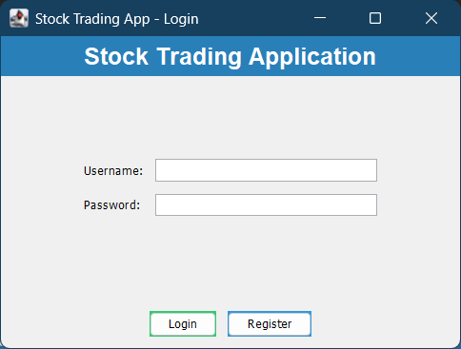
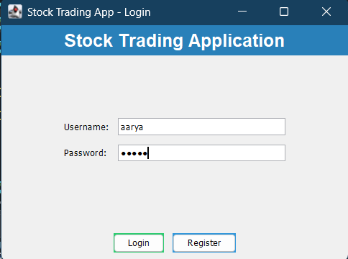

Figure 1 Login Page Figure 2 Login Page with Details
Allows registered users to log in using valid Values entered in login Page for logging in the user.
credentials. Authentication is verified before
access is granted

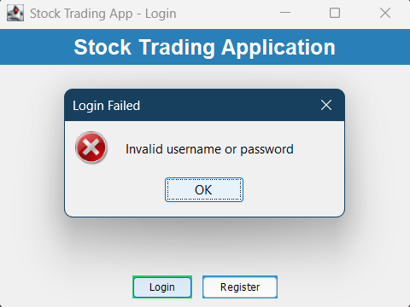

Figure 3 Invalid Authorization
Dialog pop up when Invalid Username/Password is given

- Dashboard Screen
  - Header Panel: Welcome message, logout button
  - Portfolio Summary Panel: Total value, cash balance, profit/loss
  - Holdings Table: Columns - Symbol, Quantity, Avg Price, Current Price, Total Value, Gain/Loss
  - Transactions Panel: Historical buy/sell records with timestamps
  - Prediction Panel: Stock symbol input, prediction score display, trend chart
  - Action Buttons: Buy Stock, Sell Stock, Refresh Data

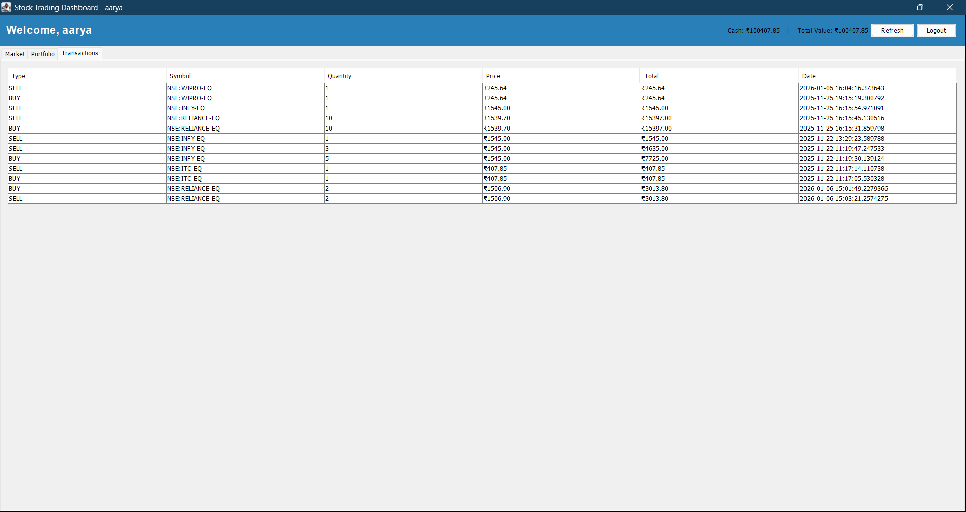
Figure 4 Dashboard Transactions Page
Lists the history of shares brought and sold over the account’s history. It shows the date of transaction and the monetary details associated with it.

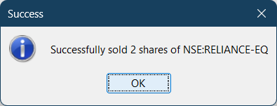

Figure 5 Sale Confirmation Dialog
Dialog box that appears when a sale is successfully sold by a user.
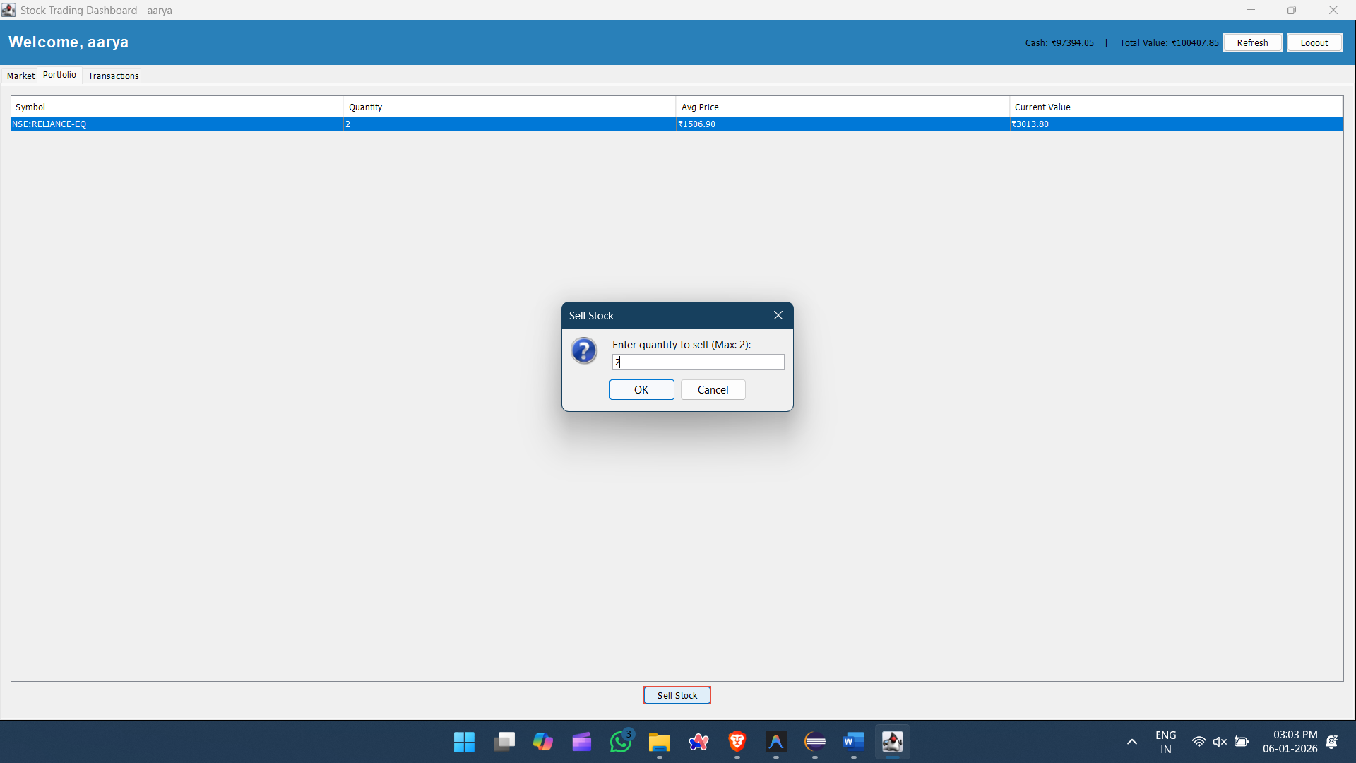
Figure 6 Sell Option
Enables the user to select a stock and select the quantity he wants to sell. If the amount of stock entered is invalid it will show the respective error.

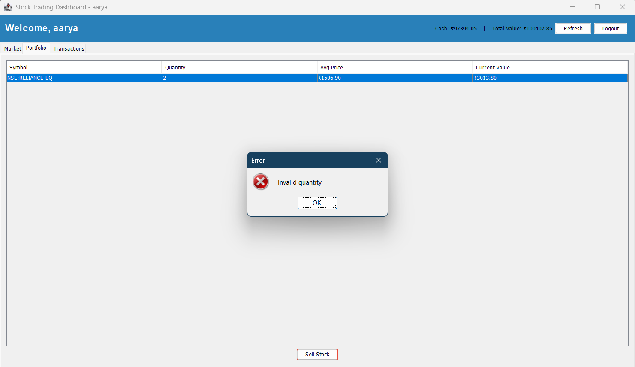
Figure 7 Invalid Stock amount dialog box
When the amount of shares to be sold entered by the user is more than what they have this dialog box appears.

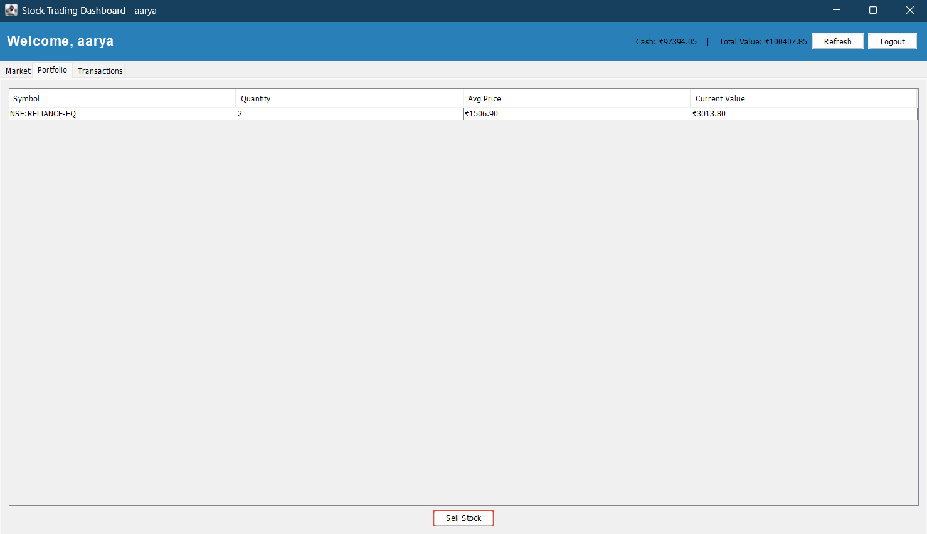
Figure 8 Portfolio Page
Portfolio Page shows all the shares owned by the user own as of that day. They can choose to sell it there, if they wish to do so.

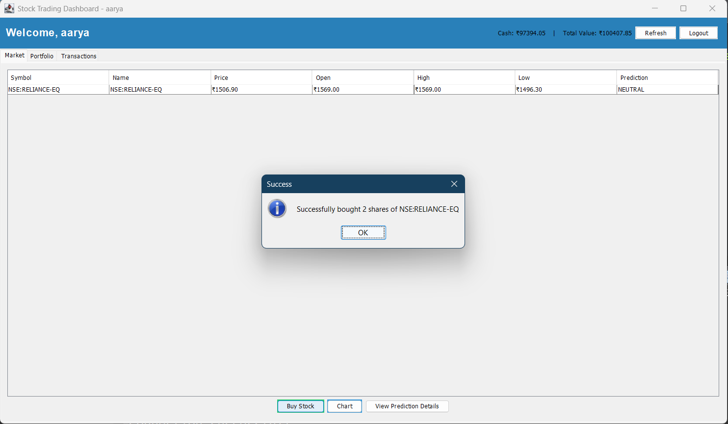

Figure 9 Buy Successful
This dialog box shows up when a trade is successful and shows that the stock has been added to the user’s portfolio.
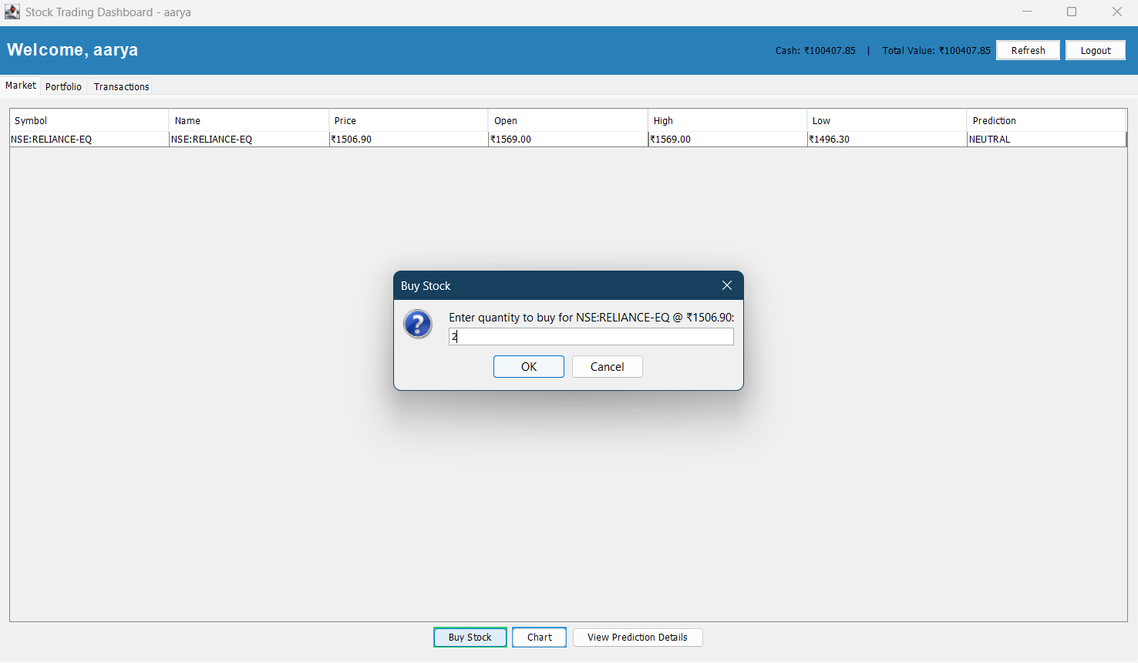
Figure 10 Buy Dialog Box
Enables a buyer to buy a stock at a said price (current price). The user may choose how many he want to purchase.

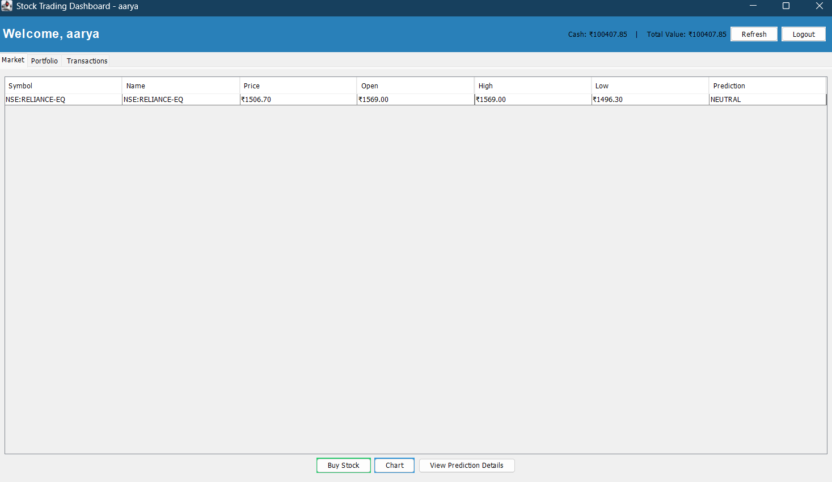
Figure 11 Main dashboard
Shows all the shares are up for trading and their current price, with all other details. Users can also see the prediction patterns to choose whether to invest or not.

Stock-1 REST API Responses
- GET /hello
- Hello from my first REST API!
- GET /auth/callback?auth_code=…
- SUCCESS! V3 Access Token received: eyJ0eXAiOiJKV1QiLCJhbGc...
- GET /fyers/quote?symbol=NSE:SBIN-EQ
- {
"s": "ok",
"d": [{
"v": {
"symbol": "NSE:SBIN-EQ",
"ltp": 456.78,
"ch": 5.30,
"chp": 1.17
}
}]
}
- GET /portfolio/holdings
- [
{
"id": 1,
"portfolioId": 1,
"symbol": "SBIN",
"quantity": 10,
"averagePrice": 350.00
},
{
"id": 2,
"portfolioId": 1,
"symbol": "RELIANCE",
"quantity": 5,
"averagePrice": 2450.50
}
]
- POST /portfolio/buy?symbol=SBIN&quantity=5
- Successfully bought 5 of SBIN

TEST CASES

StockJava (FrontEnd)
TC ID | Objective | Preconditions | Test Data / Input | Expected Result
TC-01 | User Registration | Database is initialized | Username: testuser  Password: test123  Email: test@example.com | User created in database; Success message displayed.
TC-02 | User Login - Valid | User “testuser” exists | Username: testuser  Password: test123 | Dashboard opens; Portfolio data loaded.
TC-03 | User Login - Invalid | N/A | Username: testuser  Password: wrongpass | Error message “Invalid credentials” displayed; Login form remains.
TC-04 | Buy Stock - Sufficient | User logged in;  Cash = $10,000 | Symbol: AAPL  Quantity: 10  Price: $150 | Cash reduced by $1,500; Holding added; Transaction logged as “BUY”.
TC-05 | Buy Stock- Insufficient | Cash balance = $100 | Symbol: AAPL  Quantity: 10  Price: $150 | Error “Insufficient funds” displayed; No transaction created.
TC-06 | Sell Stock - Sufficient | Portfolio has 10 AAPL | Symbol: AAPL  Quantity: 5 | Cash increased; Holding reduced to 5; Transaction logged as “SELL”.
TC-07 | Sell Stock - Insufficient | Portfolio has 3 AAPL | Symbol: AAPL  Quantity: 5 | Error “Insufficient shares” displayed; No transaction created.
TC-08 | Portfolio Value Calc | Cash: 5,000  Holdings: 10 AAPL @ 150, 5 GOOGL @ 2,800 | Action: View Dashboard (No input) | Total value displays 20,500 (5k + 1.5k + 14k).
TC-09 | Trend Prediction | N/A | Symbol: AAPL  Action: Click “Get Prediction” | Numeric trend score displayed (e.g., 0.75).
TC-10 | Database Persistence | Previous transaction completed | Action: Close app, Reopen, Log in | Holdings and transactions from previous session visible.

Stock-1 (Backend)
TC ID | Test Case Objective | Preconditions | Test Data / Input | Expected Result
TC-11 | Application Startup | N/A | Command: ./gradlew bootRun | Tomcat starts on 8080; Tables created; No errors.
TC-12 | Health Check Endpoint | App Running | Endpoint: GET /hello | Response body: “Hello from my first REST API!”.
TC-13 | Fyers OAuth Login | N/A | Endpoint: /auth/login  Action: Authorize via Fyers UI | Access token received and stored in session/DB.
TC-14 | Get Quote - Authenticated | Valid ACCESS_TOKEN exists | Endpoint: GET /fyers/quote  Params: symbol=NSE:SBIN-EQ | JSON response with keys: symbol, ltp, ch, chp.
TC-15 | Get Quote - Unauthenticated | ACCESS_TOKEN is null | Endpoint: GET /fyers/quote  Params: symbol=NSE:SBIN-EQ | Error response: “Not authenticated. Please go to /auth/login first.”
TC-16 | Get Historical Data | N/A | Endpoint: GET /fyers/history  Params: symbol=NSE:SBIN-EQ | JSON array of candle data (Date, Open, High, Low, Close, Volume).
TC-17 | Get Portfolio Holdings | Portfolio ID 1 exists | Endpoint: GET /portfolio/holdings | JSON array of Holding objects returned.
TC-18 | Buy Stock - New Holding | Portfolio 1 has 0 SBIN | Endpoint: POST /portfolio/buy  Params: symbol=SBIN, qty=10 | New row in holdings table; New transaction record; Success message.
TC-19 | Buy Stock - Existing Holding | Portfolio 1 has 10 SBIN | Endpoint: POST /portfolio/buy  Params: symbol=SBIN, qty=5 | Quantity updates to 15; Avg price recalculates; Transaction logged.
TC-20 | DB Transaction Rollback | Simulated DB Error | Endpoint: POST /portfolio/buy  Condition: Force Exception | No partial updates in DB; State remains consistent.

CONCLUSION
The Stock Trading System successfully demonstrates a comprehensive full-stack application architecture integrating desktop and web technologies. The project showcases:

Technical Achievements
- Robust Architecture: Clear separation of concerns with MVC pattern in desktop client and REST API in backend
- Database Integration: Dual database strategy (SQLite for client, PostgreSQL for server) with proper schema design and foreign key constraints
- Third-Party API Integration: Successful OAuth2 implementation with Fyers for real-time market data
- Transaction Management: ACID-compliant operations using @Transactional annotations and proper rollback handling
- Object-Oriented Design: Extensive use of interfaces, inheritance (Person → User), generics (List, Map<String, Holding>), and collections
- Concurrent Programming: Threading for asynchronous API calls in TrendPredictionService
- Security: Password hashing (SHA-256), secure credential storage, OAuth2 token management

Key Features Implemented
- User registration and authentication
- Real-time stock quote retrieval
- Historical market data visualization
- Portfolio management (buy/sell operations)
- Transaction history tracking
- Trend prediction algorithms
- Average price calculation for holdings
- Cash balance management

Areas for Enhancement
- Security Improvements:
  - Implement BCrypt for password hashing instead of plain text comparison
  - Use JWT tokens for stateless authentication instead of static ACCESS_TOKEN
  - Add HTTPS/TLS for API communication
  - Implement CSRF protection
- Feature Additions:
  - Real-time price updates using WebSockets
  - Advanced charting with technical indicators
  - Multi-portfolio support per user
  - Watchlist functionality
  - Price alerts and notifications
  - Export portfolio reports (PDF/CSV)
- Code Quality:
  - Add comprehensive unit tests (JUnit for backend, JUnit + Mockito for services)
  - Implement integration tests for API endpoints
  - Add input validation and sanitization
  - Improve error handling with custom exceptions
  - Add logging framework (SLF4J + Logback)
- Performance Optimization:
  - Implement caching for frequently accessed data (Redis)
  - Add database connection pooling (HikariCP)
  - Optimize SQL queries with indexes
  - Implement pagination for large datasets
- Deployment:
  - Containerize with Docker
  - Add CI/CD pipeline (GitHub Actions)
  - Deploy backend to cloud (AWS/Azure)
  - Add monitoring and alerting (Prometheus + Grafana)

Learning Outcomes
This project effectively demonstrates proficiency in: - Java SE (Swing, JDBC, Collections, Generics, Threads) - Java EE (Spring Boot, REST APIs, JPA/JDBC) - Database design and SQL - API integration and OAuth2 - Software design patterns - Version control (Git)
The Stock Trading System serves as a solid foundation for a production-ready financial application and showcases modern software development practices.

REFERENCES

Technologies Used
- Java 17 - Primary programming language
- Spring Boot 3.5.7 - Backend framework
- Gradle 8.14.3 - Build automation
- PostgreSQL - Relational database (backend)
- SQLite - Embedded database (client)
- Swing - GUI framework
- JDBC - Database connectivity
- RestTemplate - HTTP client
- Fyers API - Market data provider

Documentation
- Spring Boot Documentation
- Fyers API Documentation
- PostgreSQL Documentation
- Java Swing Tutorial

